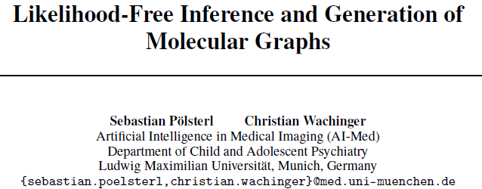

Recent methods for generating novel molecules use graph representations of molecules and employ various forms of graph convolutional neural networks for inference. However, training requires solving an expensive graph isomorphism problem, which previous approaches do not address or solve only approximately. In this work, we propose

LF-MolGAN, a likelihood-free approach for de novo molecule generation that

avoids explicitly computing a reconstruction loss.

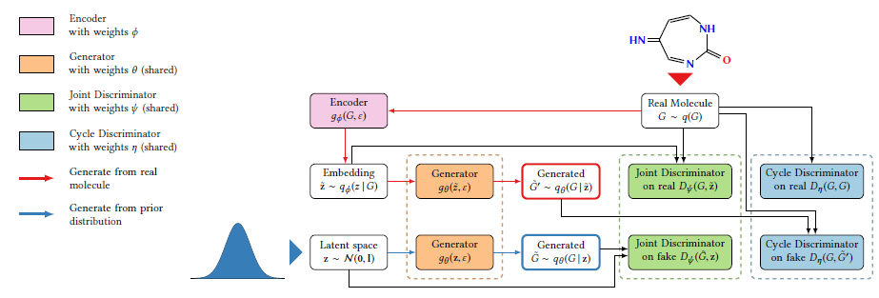

Figure 1: Overview of the proposed model.

Boxes with identical background color represent neural networks that share their weights.

The joint discriminator plays a similar role as the discriminator in standard GANs.

The cycle discriminator enforces the reconstruction property without explicitly computing a reconstruction loss.

Molecules can be generated by transforming a sample from a simple prior distribution (blue path), or by embedding a real molecule into the latent space and reconstructing its latent representation (red path).

【1,引入 cc loss】Our approach extends generative adversarial networks by including an adversarial cycle-consistency loss to implicitly enforce the reconstruction property.

【2, 多图抓分子特征】To capture properties unique to molecules, such as valence, we extend Graph Isomorphism Network to multi-graphs.

【3, 新量化指标用于评价】To quantify the performance of models, we propose to compute the distance between distributions of physicochemical properties with the 1-Wasserstein distance.

We demonstrate that LF-MolGAN more accurately learns the distribution over the space of molecules than all baselines. Moreover, it can be utilized for drug discovery by efficiently searching the space of molecules using molecules’ continuous latent representation.